What is cloud computing
- Delivery of computing services (IT resources) over the internet
Provides:
Storge
Servers
Database
Networking
Software and analytics
Instead of using our own computer or physical servers
- We can rent or use these resources from a cloud service providers on a pay as-you-go basis.
- Example: Google drive
- We can upload the files to google drive. The files stored on Google’s remote servers.
- We can access it from anywhere using the internet. We don’t need to store the file on our computer.
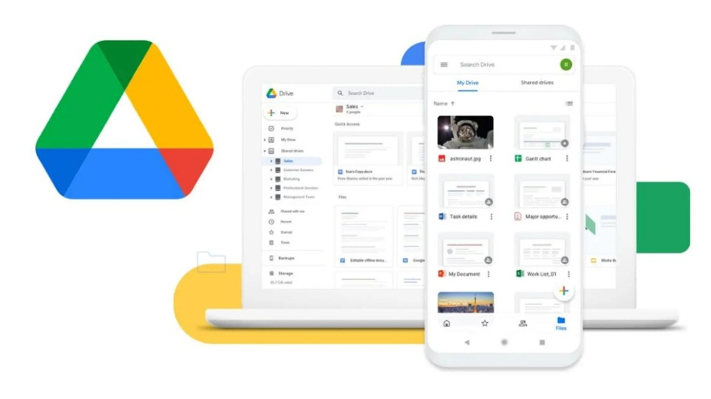

Advantages of Cloud Computing
- Cost Saving: No need to purchase expensive physical servers.
- Scalability: Increase or decrease resources whenever required.
- Accessibility: Access data from anywhere through the Internet.
- Backup: Store and recover data easily.
- Flexibility: Pay for the resources you use.
- High Availability: Applications can remain accessible using reliable cloud infrastructure.
- Mobility – Easy movement of data
- Improved collaboration

Cloud service Models
IaaS – Infrastructure as a Service
Provide virtual machine, servers, storage and networking.
In simple It provide virtualized computing resources
Example: Amazon web service EC2 instances

PaaS – Platform as a Service
Provides a platform where developers can build, test, and deploy applications without managing the underlying servers.
Example: Google App Engine for deploying web apps

SaaS – Software as a Service
Provides ready-to-use software through the Internet.
In simple It provide fully functionable applications
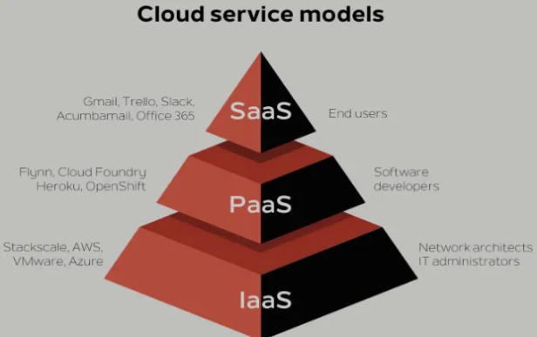
Example: Gmail provides email services via the cloud

What is Azure cloud
- Microsoft Azure is a cloud computing platform developed by Microsoft.
- Provides:
  - Virtual machines
  - Database
  - Storage
  - Networking
  - AI and data processing
Azure allows companies and developers to build, deploy, store, manage, and run applications using Microsoft's cloud infrastructure without purchasing physical servers.
Important Azure services
1.Azure virtual machines – Virtual computers to run application
2. Azure Blob storage – store files, images, video, backups, and large amount of unstructured data
3. Azure SQL Database
4. Azure Data Factory (ADF) – Build pipelines and move data
5.Azure Databricks – Big data analytics, SQL querying and data warehousing
6. Azure synapse Analytics - large-scale data analytics, SQL querying, and data warehousing.

